Report Logo

# Grammar to use:

Program = "LOGO" Identifier { Subroutine } { Statement } "END"  
  
Subroutine = "TO" Identifier { Parameter } { Statement } "END"  
  
Statement = "CS" | "PD" | "PU" | "HT" | "ST"   
 | "FD" NExpr | "BK" NExpr | "LT" NExpr | "RT" NExpr  
 | "WAIT" NExpr  
 | "REPEAT" NExpr "[" { Statement } "]"  
 | "IF" BExpr "[" { Statement } "]"  
 | "IFELSE" BExpr "[" { Statement } "]" "[" { Statement } "]"  
 | Identifier { NExpr }  
  
NExpr = NTerm { ( "+" | "-" ) NTerm }  
  
NTerm = NFactor { ( "*" | "/" ) NFactor }  
  
NFactor = "-" ( Number | REPCOUNT | Parameter | "(" NExpr ")" ) |   
 Number | REPCOUNT | Parameter | "(" NExpr ")"   
  
BExpr = BTerm { "OR" BTerm }  
  
BTerm = BFactor { "AND" BFactor }  
  
BFactor = "TRUE" | "FALSE" | "NOT" "(" BExpr ")"   
 | NExpr ( "==" | "!=" | "<" | ">" | "<=" | ">=" ) NExpr   
  
Comments start with "#" with scope until the newline  
  
Numbers are real numbers  
  
Identifiers start with a letter followed by letters or digits  
  
Parameters are ":" followed by Identifier  
  
Identifiers, parameters, keywords in uppercase only

# Introduction:

22.05.2020

Installed and set “ant” and “java8”.

First I looked at how the Logo.jj file works.

Once I understood this, I started by adding the two methods for subroutines and statements.

I started translating the grammar for subroutines and statements and also for all other voids like nexpr.

24.05.2020

The first problem I had was when I had to add the number. Because I was able to write all the expressions but I was stuck on the Factor expressions.

In fact, I couldn't print the number here. Once I was able to solve the problem, I noticed that the function was called twice to print the number.

So, I wrote a function so that I only had to call this one for the times I needed it and not write it all down every time.

I also used this method for other functions that were repeated in the code, so as not to have useless double code.

26.05.2020

Solved this problem, I was able to run some logo files and I was able to do some tests.

Another difficulty was for the Repeat in fact, I was able to do the function for a normal for, but now I'm stuck for a nested for, I'm trying to figure out how to add a variable so that when the function is called the second time the variable does not overwrite.

02.06.2020

I've created a test file, to test +,-,*,/

.

LOGO FACTOR  
 FD 1 + 2  
 FD 1 * 1  
 FD 1 - 1  
 FD 1 / 1  
END

After I went out to find a solution, I tested the functions on the polygon.logo file,

I had some problems in the polygon.logo file, when I couldn't print the split.

Before:

private void poly(double SIDES){  
 for(int i = 0; i <= SIDES; i++){  
 logo.fd(50);  
 logo.rt(360SIDES);  
 }  
}

After:

logo.rt(360/SIDES);

Everything works.

09.06.2020

I had trouble with the REPEAT part:

<REPEAT>{indent(); pw.print("for(int i = 0; i <= ");} nexpr() {pw.println("; i++){");numIndent++;} <LBRA> (statement())* <RBRA> {numIndent--; indent();pw.println("}");}

This was my first test to see if it worked, and for single cycles it works great.

The problem is with nested cycles.

I declared a REPCOUNT variable:

I applied a counter to add a number:

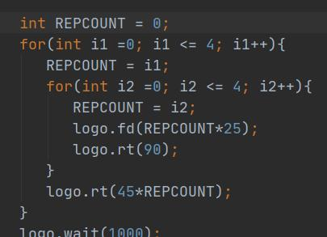

My problem at the moment is that I can't decrease REPCOUNT correctly, while the counter is no problem:

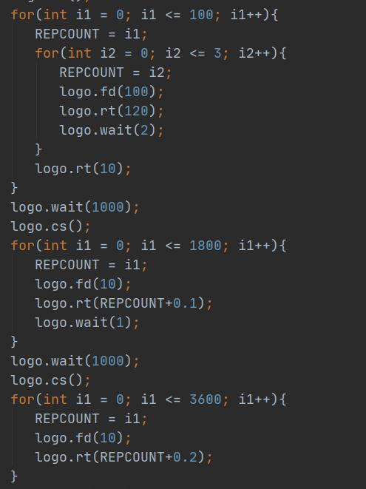

I added a line for REPCOUNT, that decrease the count.

Demo.logo works!